
International School

Capstone Project 1
CMU-SE 450

User Interface Design
Version 1.3
Date: 15/11/2021

Online Clinic Booking System

Submitted by

Truong Gia Huy
Ngo Van Kha
Le Van Xuan
Tran Nguyen Thanh Hong

Capstone Project 1 - Mentor:
Master Nguyen Tan Thuan Date:
Signature
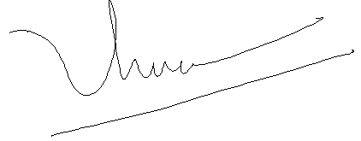

Project Information

Project acronym | OnClinic
Project Title | Online Clinic Booking System
Start Date | 15 Aug 2021 | End Date | 15 Dec 2021
Lead Institution | International School, Duy Tan University
Project Mentor | Master Thuan, Nguyen Tan  Email: nguyentanthuan@dtu.edu.vn
Scrum master / Project Leader & contact details | Ngo Van Kha – 24211210573  Email: ngokha437@gmail.com  Tel: 0935950384
Partner Organization | N/A
Team Members
Student ID | Name | Email | Tel
24211206450 | Truong Gia Huy | truonggiahuy7799@gmail.com | 0972173687
24207106137 | Tran Nguyen Thanh Hong | thanhhong24102000@gmail.com | 0782363961
24211207159 | Le Van Xuan | levanxuan5518@gmail.com | 0905596460

Document Information

Document Title | Interface Design
Reporting Period
Author(s) | Truong Gia Huy, Ngo Van Kha, Le Van Xuan, Tran Nguyen Thanh Hong
Team members | Name:
Team members | Truong Gia Huy
Team members | Le Van Xuan
Team members | Ngo Van Kha
Team members | Tran Nguyen Thanh Hong
Date | 15/11/2021
File name | C1SE.37-InterfaceDesign-OnClinic
Access | Project and CMU Program

Document History
Version | Date | Comments
V1.0 | 04/09/2021 | Create Architecture Document
V1.1 | 15/10/2021 | Editing
V1.2 | 05/11/2021 | Editing
V1.3 | 15/11/2021 | Completing the document

Table of contents

Project Information 2

Document Information 3

Table of contents 4

1. Introduction 6

1.1 Purpose 6

1.2 Scope 6

1.3 Tool 6

2. Describe User Interface Application in Detail 8

2.1 Sign up – login – forgot password 8

2.1.1 Greeting 8

2.1.2 Sign up 9

2.1.3 Login 10

2.1.4 Forgot password 11

2.2 UI for patient role 12

2.2.1 Home 12

2.2.2 Navigation Drawer 13

2.2.3 Booking Clinic step 1 14

2.2.4 Booking Clinic step 2 15

2.2.5 Clinic profile 16

2.2.6 Upcoming appointment 17

2.2.7 Measure heartbeat 18

2.2.8 Measure heartbeat result 19

2.2.9 History 20

2.2.10 User’s profile 21

2.2.11 Editting user’s profile dialog 22

2.2.12 Change user’s password 23

2.2.13 Editting user’s payment information 24

2.2.14 Notification 25

2.2.15 Online examination through video call 26

2.2.16 View clinic’s feedback 27

2.2.17 Write feedback for clinic 28

2.2.18 Contact us 29

2.2.19 Application feedback dialog 30

2.2.20 Create clinic 31

2.3 UI for doctor role 32

2.3.1 Home 32

2.3.2 Navigation Drawer 33

2.3.3 User’s profile 34

2.3.4 Editting profile dialog 35

2.3.5 Change password dialog 36

2.3.6 Editting user payment information dialog 37

2.3.7 Doctor’s schedule 38

2.3.8 Patient’s profile viewing page 39

2.3.9 Online examination 40

2.3.10 Clinic management 41

2.3.11 Clinic’s profile 42

2.3.12 Editting clinic’s profile dialog 43

2.3.13 Feedback (View from doctor) 44

2.3.14 Notification 45

2.3.15 Examination slot created 46

2.3.16 Edit examination slot 47

2.3.17 Create prescription 48

2.3.18 Examination history 49

2.3.19 Measure Heartbeat 50

2.3.20 Measure Heartbeat result 51

2.3.21 Contact us 52

2.3.22 Application feedback dialog 53

1. Introduction

1.1 Purpose
This document serves the purpose of specifying application’s UI design

1.2 Scope
- Create complete interfaces, and describe them clearly.
- Overview of the stages and modules of the system.

1.3 Tool
Figma tool

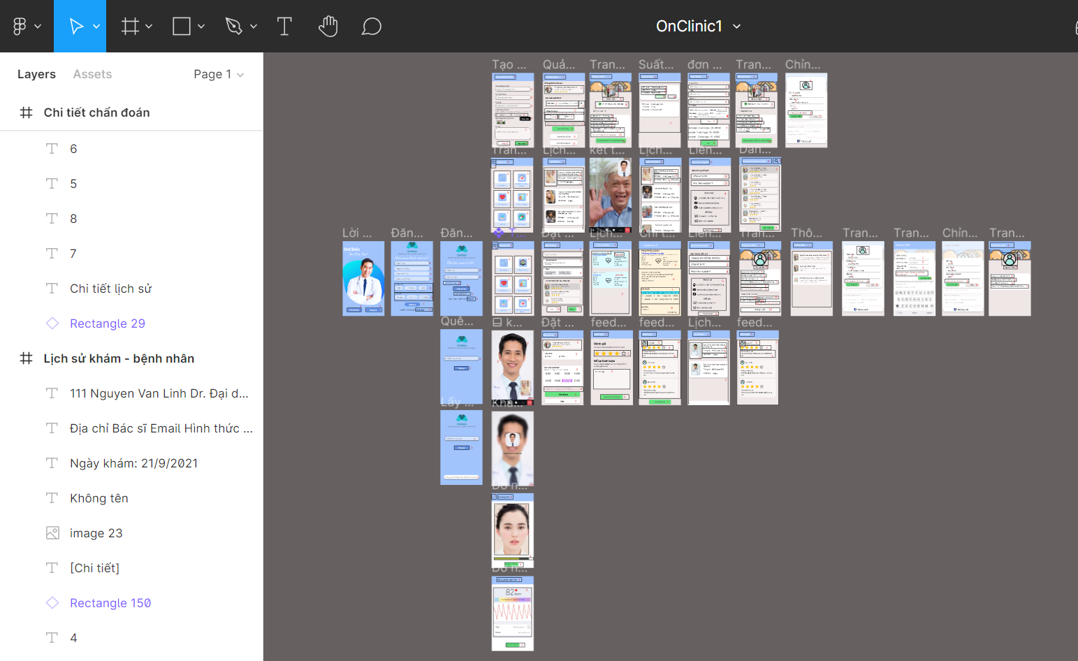

Figure: Overview of team’s works on Figma

2. Describe User Interface Application in Detail

2.1 Sign up – login – forgot password

2.1.1 Greeting

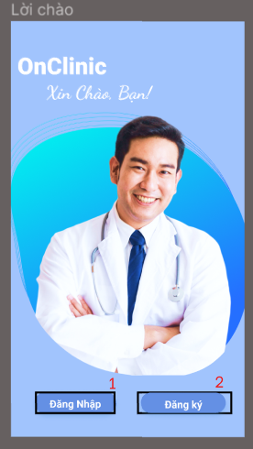

ID | Condition | Control Type | Target | Notes
1 | Press | Button | Move to login view
2 | Press | Button | Move to sign-up view

2.1.2 Sign up
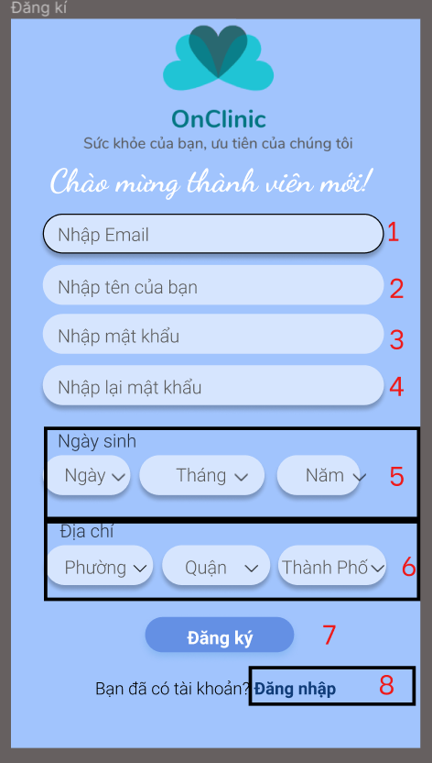

ID | Condition | Control Type | Target | Notes
1 | Texting | TextBox | Enter email
2 | Texting | TextBox | Enter name
3 | Texting | TextBox | Enter password
4 | Texting | TextBox | Re-enter password
5 | Select | Spinner | Select birthday
6 | Select | Spinner | Select address
7 | Press | Button | Verify registration, then move to login page
8 | Press | TextView | Move to login page

2.1.3 Login
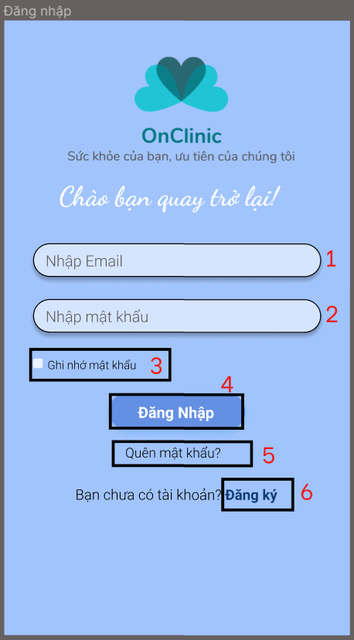

ID | Condition | Control Type | Target | Notes
1 | Texting | TextBox | Enter email
2 | Texting | TexBox | Enter password
3 | Select | RadioButton | Select to remember user’s password for next time login
4 | Press | Button | Verify login and user role, then move in home page
5 | Press | TextView | Move to forgot password page
6 | Press | TextView | Move to sign up page

2.1.4 Forgot password
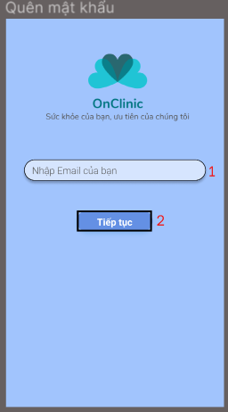

ID | Condition | Control Type | Target | Notes
1 | Texting | TextBox | Enter user’s email
2 | Press | Button | Send change-password link to user mail, move to login page

2.2 UI for patient role

2.2.1 Home

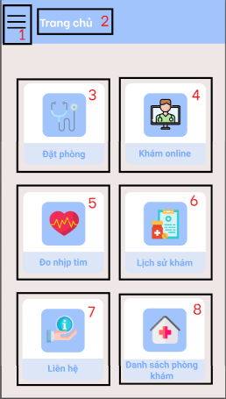

ID | Condition | Control Type | Target
1 | Press | Button | Open navigation drawer
2 | Nothing | TextView | Show page’s name
3 | Press | Button | Move to Booking Clinic page
4 | Press | Button | Move to Upcoming Appointment page
5 | Press | Button | Move to Measure Heartbeat page
6 | Press | Button | Move to History page
7 | Press | Button | Move to Contact Us page
8 | Press | Button | Move to clinic list page

2.2.2 Navigation Drawer

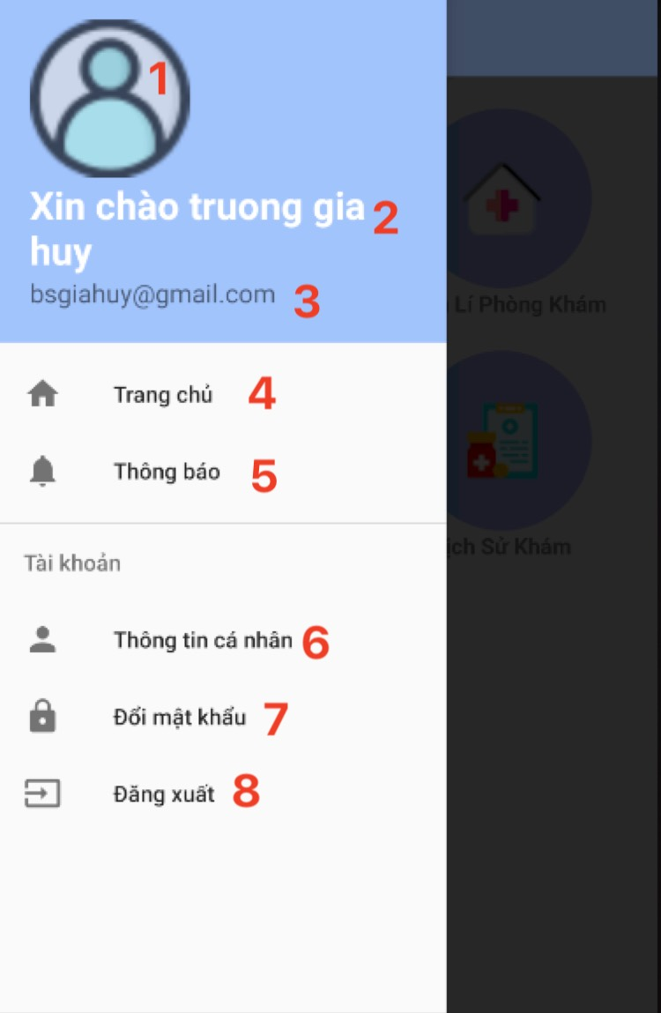

ID | Condition | Control Type | Target
1 | Nothing | ImageView | Show user’s avatar
2 | Nothing | TextView | Show user’s name
3 | Nothing | TextView | Show user’s email
4 | Press | Button | Move to home page
5 | Press | Button | Move to notification page
6 | Press | Button | Move to user’s profile page
7 | Press | Button | The change password dialog show up
8 | Press | Button | Log out the account, move to greeting page

2.2.3 Booking Clinic step 1

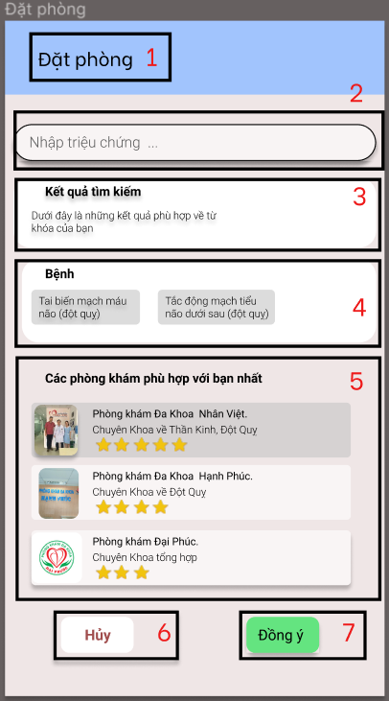

ID | Condition | Control Type | Target
1 | Nothing | TextView | Show page’s name
2 | Texting | TextBox | Enter patient’s symptoms
3 | Nothing | TextView | Show if the diagnose process is done
4 | Nothing | TextView | Show diagnose results
5 | Select | RecycleView | Show suitable clinic for patient, select prefer clinic will move to clinic’s profile page
6 | Press | Button | Move back to home page
7 | Press | Button | Move to Booking Clinic step 2

2.2.4 Booking Clinic step 2

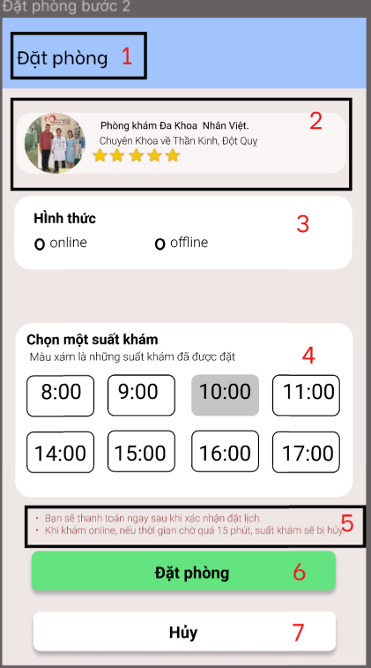

ID | Condition | Control Type | Target
1 | Nothing | TextView | Show page’s name
2 | Press | LinearLayout | Overview of clinic profile, pressing will move to detail clinic profile
3 | Select | LinearLayout | Select which form you want to take examination (online or ofline)
4 | Select | LinearLayout | Show time slot of the clinic
5 | Nothing | TextView | Show some things to notice when booking clinic
6 | Press | Button | Confirm booking, move to home page, show toast notify that booking successful.
7 | Press | Button | Move back to booking clinic step 1

2.2.5 Clinic profile

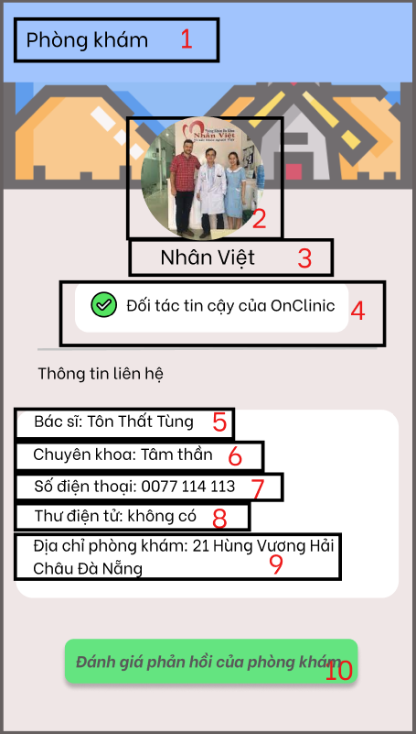

ID | Condition | Control Type | Target
1 | Nothing | TextView | Show page’s name
2 | Nothing | ImageView | Show clinic’s avatar
3 | Nothing | TextView | Show clinic’s name
4 | Nothing | LinearLayout | Clinic certification
5 | Nothing | TextView | Show clinic’s doctor
6 | Nothing | TextView | Show clinic’s speciality
7 | Nothing | TextView | Show clinic’s phone number
8 | Nothing | TextView | Show clinic’s email
9 | Nothing | TextView | Show clinic’s address
10 | Press | Button | Move to clinic feedback page

2.2.6 Upcoming appointment

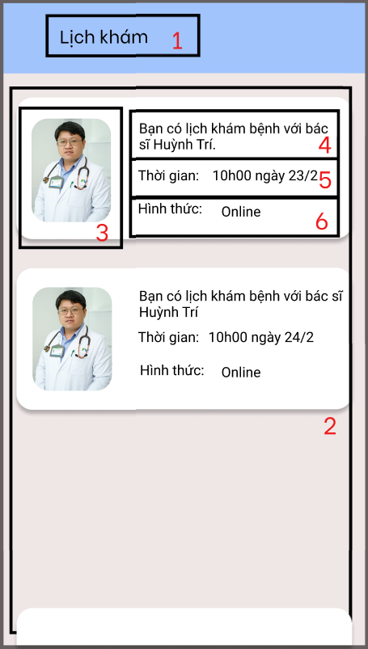

ID | Condition | Control Type | Target
1 | Nothing | TextView | Show page’s name
2 | Select | RecycleView | Show upcoming appointment, select which appointment that patient want to take, if the form is online then move to online examination through video call
3 | Nothing | ImageView | Show doctor’s avatar
4 | Nothing | TextView | Show doctor’s name
5 | Nothing | TextView | Show time of upcoming appointment
6 | Nothing | TextView | Show form of upcoming appointment (on/off line)

2.2.7 Measure heartbeat

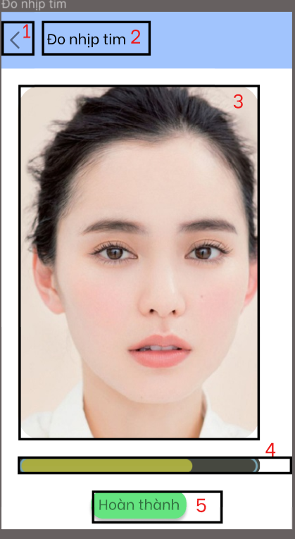

ID | Condition | Control Type | Target
1 | Press | Button | Move back to home page
2 | Nothing | TextView | Show page’s name
3 | Nothing | Camera | Serves to measure the rate of news
4 | Nothing | LinearLayout | Show measure process
5 | Nothing | Toast | Show if the measure process is successful

2.2.8 Measure heartbeat result

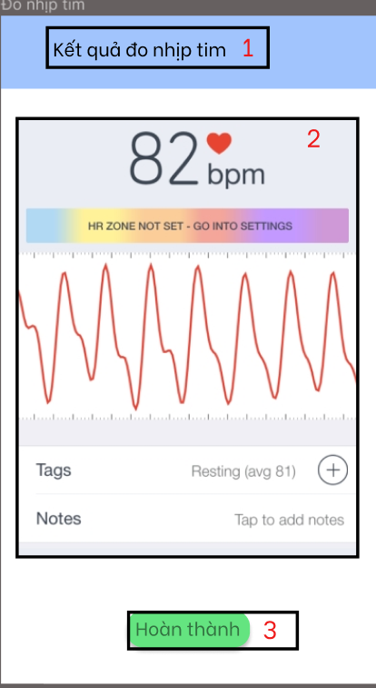

ID | Condition | Control Type | Target
1 | Nothing | TextView | Show page’s name
2 | Nothing | LinearLayout | Show measure result
3 | Press | Button | Move to home page

2.2.9 History

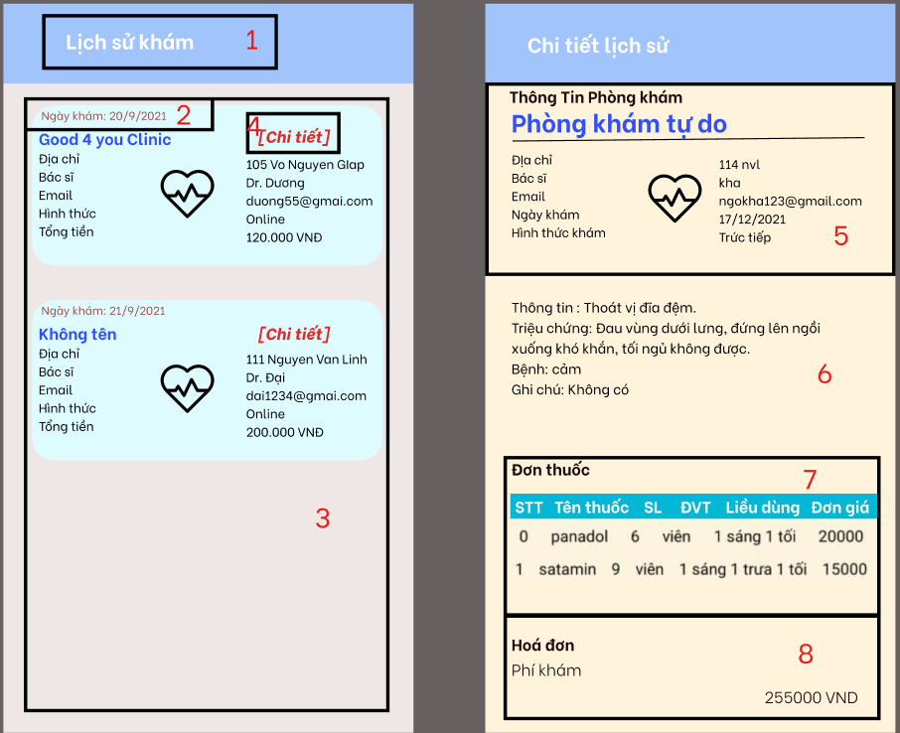

ID | Condition | Control Type | Target
1 | Nothing | TextView | Show page’s name
2 | Nothing | TextView | Show date of examination
3 | Nothing | RecycleView | Show passed examination
4 | Press | TextView | Show detail of examination results
5 | Nothing | TableLayout | Show clinic information
6 | Nothing | LinearLayout | Show detail of examination results
7 | Nothing | TextView | Show prescription
8 | Press | TextView | Show bill

2.2.10 User’s profile

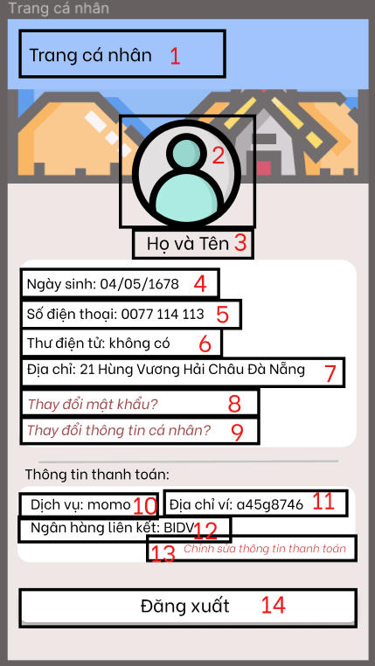

ID | Condition | Control Type | Target
1 | Nothing | TextView | Show page’s name
2 | Nothing | ImageView | Show user’s avatar
3 | Nothing | TextView | Show user’s name
4 | Nothing | TextView | Show user’s birthday
5 | Nothing | TextView | Show user’s phone number
6 | Nothing | TextView | Show user’s mail
7 | Nothing | TextView | Show user’s address
8 | Press | TextView | Change password dialog show up
9 | Press | TextView | Change profile information dialog show up
10 | Nothing | TextView | Show user’s payment serviece
11 | Nothing | TextView | Show user’s payment address
12 | Nothing | TextView | Show user’s payment bank
13 | Press | TextView | Change payment information dialog show up
14 | Press | Button | Log out the account, move to greeting page

2.2.11 Editting user’s profile dialog

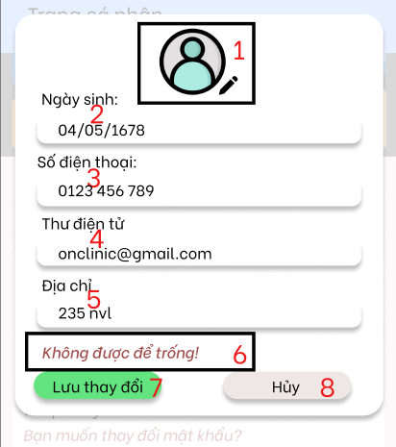

ID | Condition | Control Type | Target
1 | Press | ImageView | Change user’s avatar
2 | Press | TextBox | DatePicker show up, change user’s birthday
3 | Texting | TextBox | Enter new user’s phone number
4 | Texting | TextBox | Enter new user’s email
5 | Texting | TextBox | Enter new user’s address
6 | Nothing | TextView | Show alert if there is any problem
7 | Press | Button | Save changed information, move back to profile page
8 | Press | Button | Turn off changed information dialog

2.2.12 Change user’s password

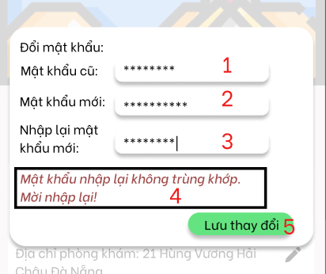

ID | Condition | Control Type | Target
1 | Texting | TextBox | Enter old password
2 | Texting | TextBox | Enter new password
3 | Texting | TextBox | Re-enter new password
4 | Nothing | TextView | Show alert if there is any problem
5 | Press | Button | Change user’s passoword

2.2.13 Editting user’s payment information

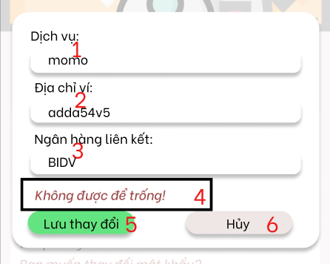

ID | Condition | Control Type | Target
1 | Texting | TextBox | Enter new user’s payment service brand
2 | Texting | TextBox | Enter new user’s payment service address
3 | Texting | TextBox | Enter new user’s payment linking bank
4 | Nothing | TextView | Show alert if there is any problem
5 | Press | Button | Save changed information, move back to profile page
6 | Press | Button | Turn off dialog

2.2.14 Notification

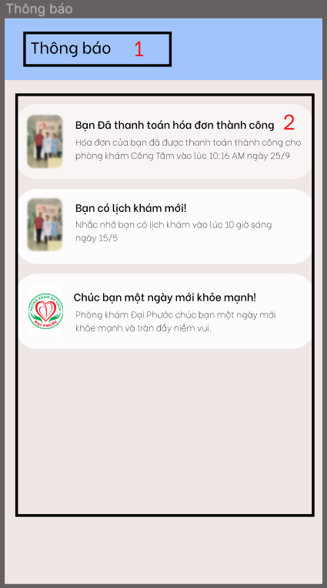

ID | Condition | Control Type | Target
1 | Nothing | TextView | Show page’s name
2 | Select | RecycleView | Show notification

2.2.15 Online examination through video call

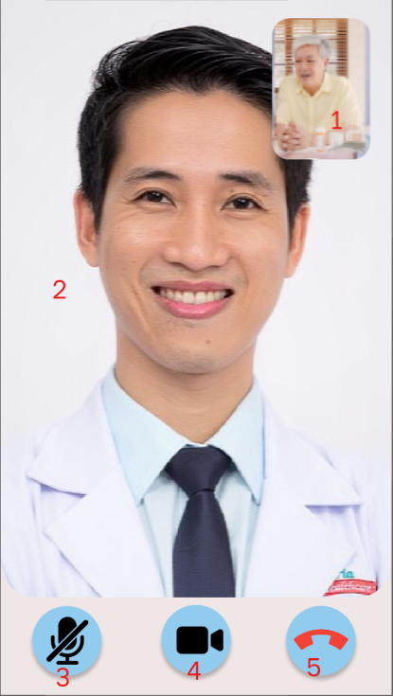

ID | Condition | Control Type | Target
1 | Nothing | Video | Display the patient
2 | Nothing | Video | Display the doctor
3 | Press | Button | Turn off/on the micro
4 | Press | Button | Turn off/on the video
5 | Press | Button | End the video call

2.2.16 View clinic’s feedback

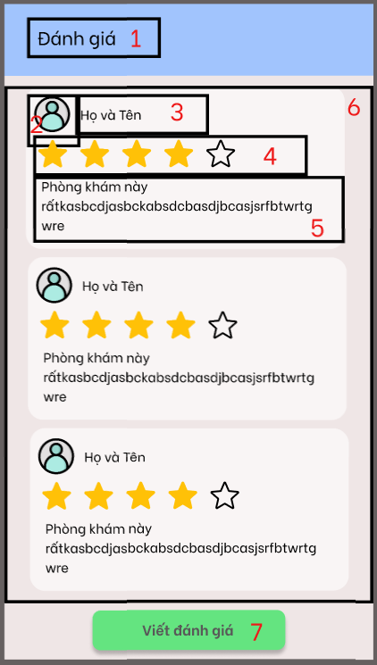

ID | Condition | Control Type | Target
1 | Nothing | TextView | Show page’s name
2 | Nothing | ImageView | Show responder’s avatar
3 | Nothing | TextView | Show responder’s name
4 | Nothing | RatingBar | Show rating
5 | Nothing | TextView | Show feedback in detail
6 | Nothing | RecycleView | Show all the feedbacks
7 | Press | Button | Move to Write feedback page

2.2.17 Write feedback for clinic

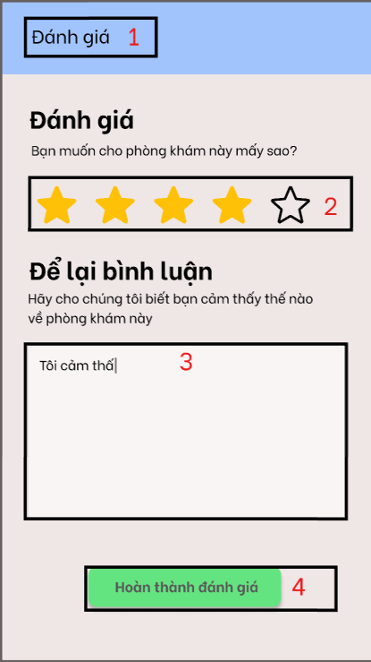

ID | Condition | Control Type | Target
1 | Nothing | TextView | Show page’s name
2 | Select | RatingBar | Select rating
3 | Texting | EditText | Enter the feedback in detail
4 | Press | Button | Post the feedback, move to clinic’s feedback page

2.2.18 Contact us

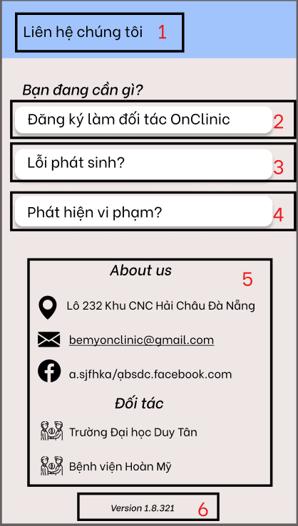

ID | Condition | Control Type | Target
1 | Nothing | TextView | Show page’s name
2 | Press | Button | Move to Create clinic page
3 | Press | Button | The application feedback dialog show up
4 | Press | Button | The application feedback dialog show up
5 | Nothing | TextView | Show application’s information
6 | Nothing | TextView | Show the version of the app

2.2.19 Application feedback dialog

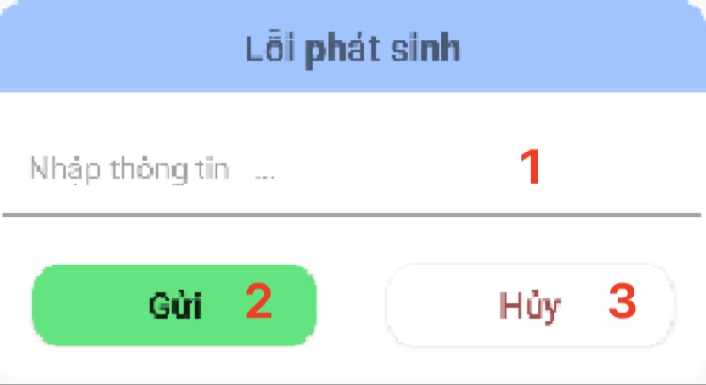

ID | Condition | Control Type | Target
1 | Texting | EditText | Enter the feedback for application
2 | Press | Button | Sending the feedback to admin
3 | Press | Button | Cancel feedback dialog

2.2.20 Create clinic

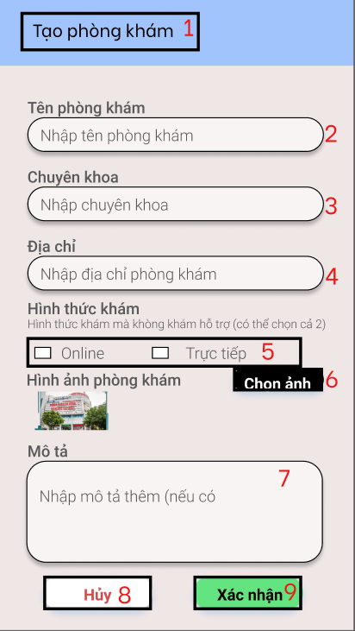

ID | Condition | Control Type | Target
1 | Nothing | TextView | Show page’s name
2 | Texting | EditText | Enter the new clinic’s name
3 | Texting | EditText | Enter the new clinic’s specialist
4 | Texting | EditText | Enter the new clinic’s address
5 | Select | RadioButton | Select the form of the examination that clinic will support
6 | Press | Button | Upload avatar of the new clinic
7 | Texting | EditText | Enter description of the new clinic
8 | Press | Button | Cancel clinic creation
9 | Press | Button | Confirm clinic creation

2.3 UI for doctor role

2.3.1 Home

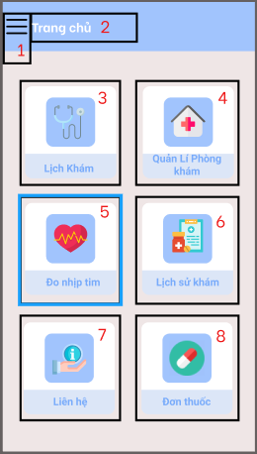

ID | Condition | Control Type | Target
1 | Press | Button | Open navigation drawer
2 | Nothing | TextView | Show page’s name
3 | Press | Button | Move to Doctor schedule page
4 | Press | Button | Move to Clinic management page
5 | Press | Button | Move to Measure heartbeat page
6 | Press | Button | Move to Examination history page
7 | Press | Button | Move to Contact Us page
8 | Press | Button | Move to precription page

2.3.2 Navigation Drawer

ID | Condition | Control Type | Target
1 | Nothing | ImageView | Show user’s avatar
2 | Nothing | TextView | Show user’s name
3 | Nothing | TextView | Show user’s email
4 | Press | Button | Move to home page
5 | Press | Button | Move to notification page
6 | Press | Button | Move to user’s profile page
7 | Press | Button | The change password dialog show up
8 | Press | Button | Log out the account, move to greeting page

2.3.3 User’s profile

ID | Condition | Control Type | Target
1 | Nothing | TextView | Show page’s name
2 | Nothing | ImageView | Show user’s avatar
3 | Nothing | TextView | Show user’s name
4 | Nothing | TextView | Show user’s birthday
5 | Nothing | TextView | Show user’s phone number
6 | Nothing | TextView | Show user’s mail
7 | Nothing | TextView | Show user’s address
8 | Press | TextView | Change password dialog show up
9 | Press | TextView | Change profile information dialog show up
10 | Nothing | TextView | Show user’s payment serviece
11 | Nothing | TextView | Show user’s payment address
12 | Nothing | TextView | Show user’s payment bank
13 | Press | TextView | Change payment information dialog show up
14 | Press | Button | Log out the account, move to greeting page

2.3.4 Editting profile dialog

ID | Condition | Control Type | Target
1 | Press | ImageView | Change user’s avatar
2 | Press | TextBox | DatePicker show up, change user’s birthday
3 | Texting | TextBox | Enter new user’s phone number
4 | Texting | TextBox | Enter new user’s email
5 | Texting | TextBox | Enter new user’s address
6 | Nothing | TextView | Show alert if there is any problem
7 | Press | Button | Save changed information, move back to profile page
8 | Press | Button | Turn off changed information dialog

2.3.5 Change password dialog

ID | Condition | Control Type | Target
1 | Texting | TextBox | Enter old password
2 | Texting | TextBox | Enter new password
3 | Texting | TextBox | Re-enter new password
4 | Nothing | TextView | Show alert if there is any problem
5 | Press | Button | Change user’s passoword

2.3.6 Editting user payment information dialog

ID | Condition | Control Type | Target
2 | Texting | TextBox | Enter new user’s payment service brand
3 | Texting | TextBox | Enter new user’s payment service address
4 | Texting | TextBox | Enter new user’s payment linking bank
5 | Nothing | TextView | Show alert if there is any problem
6 | Press | Button | Save changed information, move back to profile page
7 | Press | Button | Turn off dialog

2.3.7 Doctor’s schedule

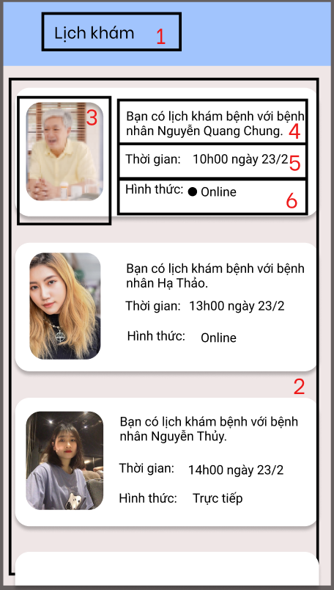

ID | Condition | Control Type | Target
1 | Nothing | TextView | Show page’s name
2 | Select | RecycleView | Show upcoming appointment, select which appointment that doctor want to take, if the form is online then move to online examination through video call
3 | Press | ImageView | Move to patient’s profile viewing page
4 | Nothing | TextView | Show patient’s name
5 | Nothing | TextView | Show time of upcoming appointment
6 | Nothing | TextView | Show form of upcoming appointment (on/off line)

2.3.8 Patient’s profile viewing page

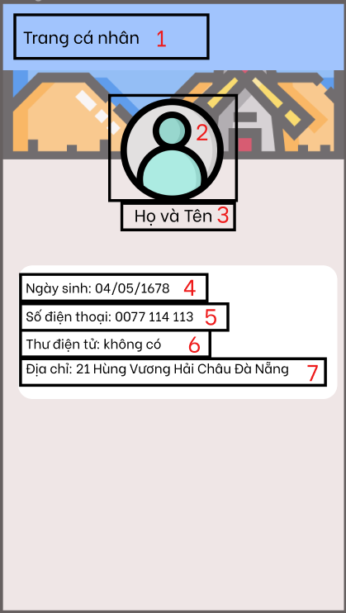

ID | Condition | Control Type | Target
1 | Nothing | TextView | Show page’s name
2 | Nothing | ImageView | Show user’s avatar
3 | Nothing | TextView | Show user’s name
4 | Nothing | TextView | Show user’s birthday
5 | Nothing | TextView | Show user’s phone number
6 | Nothing | TextView | Show user’s mail
7 | Nothing | TextView | Show user’s address

2.3.9 Online examination

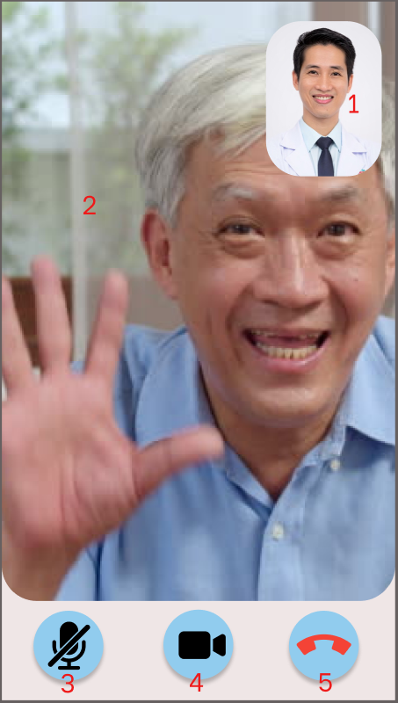

ID | Condition | Control Type | Target
1 | Nothing | Video | Display the doctor
2 | Nothing | Video | Display the patient
3 | Press | Button | Turn off/on the micro
4 | Press | Button | Turn off/on the video
5 | Press | Button | End the video call

2.3.10 Clinic management

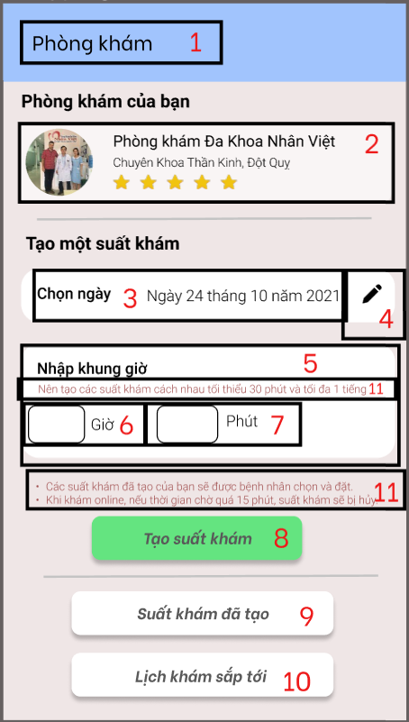

ID | Condition | Control Type | Target
1 | Nothing | TextView | Show page’s name
2 | Select | RecycleView | Show upcoming appointment, select which appointment that doctor want to take, if the form is online then move to online examination through video call
3 | Nothing | ImageView | Show patient’s avatar
4 | Nothing | TextView | Show patient’s name
5 | Nothing | TextView | Show time of upcoming appointment
6 | Nothing | TextView | Show form of upcoming appointment (on/off line)

2.3.11 Clinic’s profile

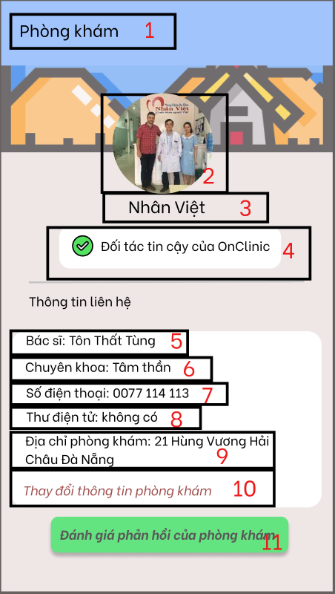

ID | Condition | Control Type | Target
1 | Nothing | TextView | Show page’s name
2 | Nothing | ImageView | Show clinic’s avatar
3 | Nothing | TextView | Show clinic’s name
4 | Nothing | LinearLayout | Clinic certification
5 | Nothing | TextView | Show clinic’s doctor
6 | Nothing | TextView | Show clinic’s speciality
7 | Nothing | TextView | Show clinic’s phone number
8 | Nothing | TextView | Show clinic’s email
9 | Nothing | TextView | Show clinic’s address
10 | Press | TextView | The editting clinic’s profile show up
11 | Press | Button | Move to clinic feedback page (Doctor view)

2.3.12 Editting clinic’s profile dialog

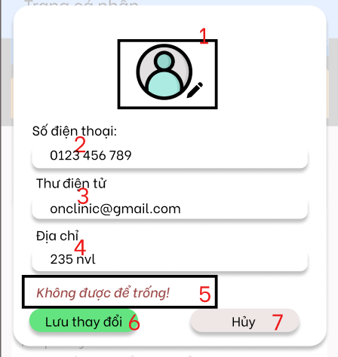

ID | Condition | Control Type | Target
1 | Press | ImageView | Change user’s avatar
2 | Texting | TextBox | Enter new clinic’s phone number
3 | Texting | TextBox | Enter new clinic’s email
4 | Texting | TextBox | Enter new clinic’s address
5 | Nothing | TextView | Show alert if there is any problem
6 | Press | Button | Save changed information, move back to profile page
7 | Press | Button | Turn off changed information dialog

2.3.13 Feedback (View from doctor)

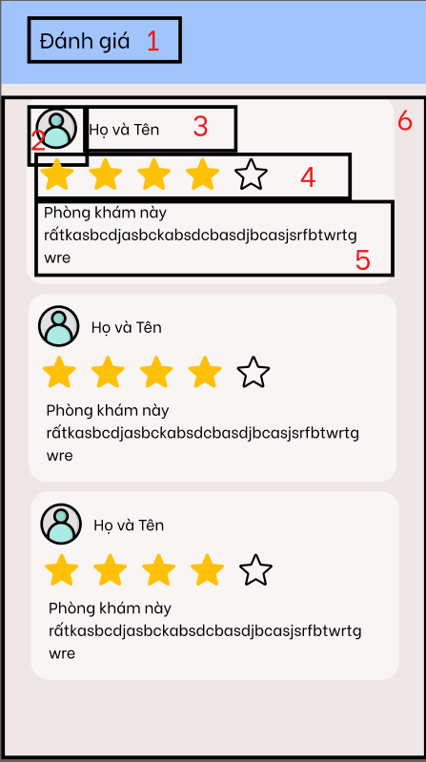

ID | Condition | Control Type | Target
1 | Nothing | TextView | Show page’s name
2 | Nothing | ImageView | Show responder’s avatar
3 | Nothing | TextView | Show responder’s name
4 | Nothing | RatingBar | Show rating
5 | Nothing | TextView | Show feedback in detail
6 | Nothing | RecycleView | Show all the feedbacks

2.3.14 Notification

ID | Condition | Control Type | Target
1 | Nothing | TextView | Show page’s name
2 | Select | RecycleView | Show notification

2.3.15 Examination slot created

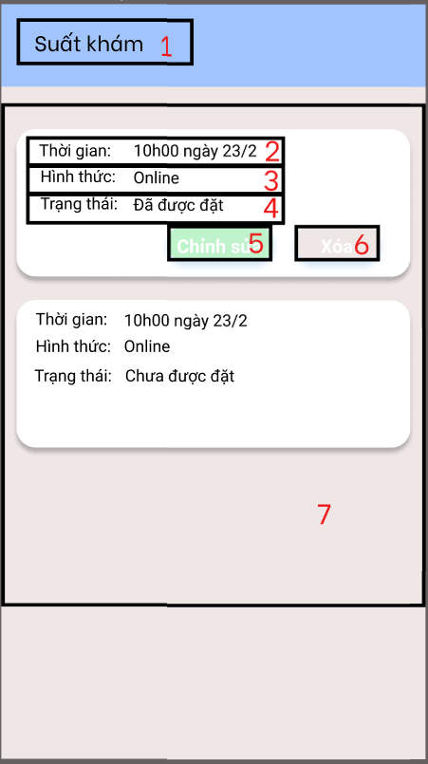

ID | Condition | Control Type | Target
1 | Nothing | TextView | Show page’s name
2 | Select | TextView | Show slot’s time
3 | Nothing | TextView | Show slot’s from
4 | Nothing | TextView | Show slot’s status (booked or not booked)
5 | Press | Button
6 | Press | Button | Delete slot
7 | Select | RecycleView | Show upcoming appointment, select which appointment that doctor want to take, if the form is online then move to online examination through video call

2.3.16 Edit examination slot

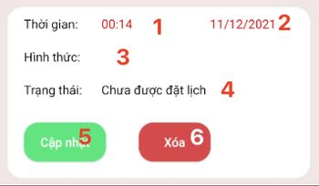

ID | Condition | Control Type | Target
1 | Select | EditText | Edit time of the slot
2 | Select | EditText | Edit date of the slot
3 | Nothing | TextView | Show form of the slot (online or offline)
4 | Nothing | TextView | Show the situation of the slot
5 | Press | Button | Update the information of the slot
6 | Press | Button | Delete this examination slot

2.3.17 Create prescription

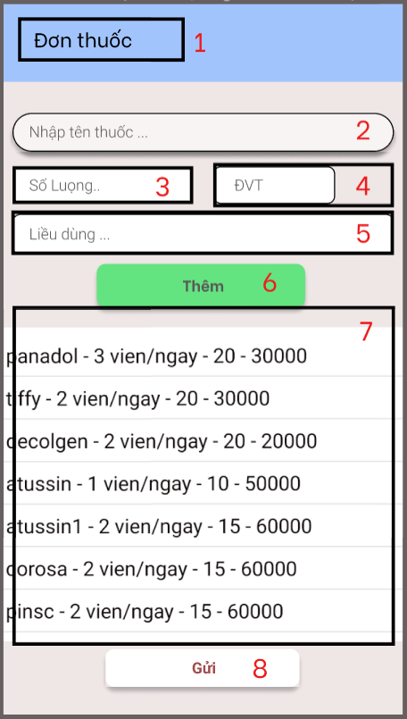

ID | Condition | Control Type | Target
1 | Nothing | TextView | Show page’s name
2 | Select | TextView | Show slot’s time
3 | Nothing | TextView | Show slot’s from
4 | Nothing | TextView | Show slot’s status (booked or not booked)
5 | Press | Button
6 | Press | Button | Delete slot
7 | Select | RecycleView | Show upcoming appointment, select which appointment that doctor want to take, if the form is online then move to online examination through video call

2.3.18 Examination history

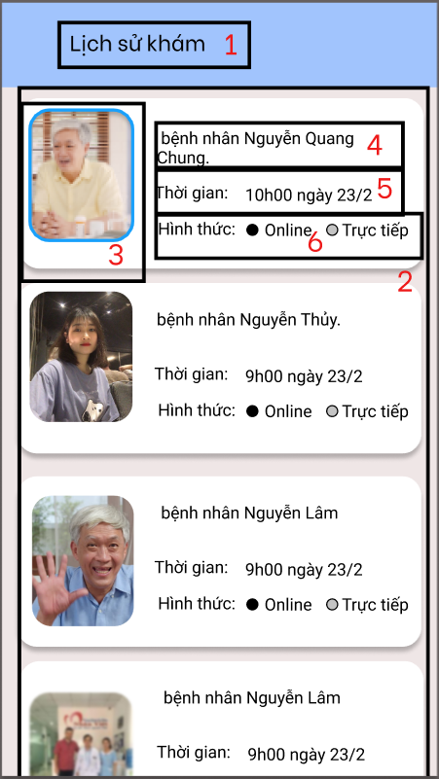

ID | Condition | Control Type | Target
1 | Nothing | TextView | Show page’s name
2 | Select | RecycleView | Show passed appointment
3 | Press | ImageView | Move to patient’s profile viewing page
4 | Nothing | TextView | Show patient’s name
5 | Nothing | TextView | Show time of passed appointment
6 | Nothing | TextView | Show form of passed appointment (on/off line)

2.3.19 Measure Heartbeat

ID | Condition | Control Type | Target
1 | Press | Button | Move back to home page
2 | Nothing | TextView | Show page’s name
3 | Nothing | Camera | To measure heartbeat
4 | Nothing | LinearLayout | Show measure process
5 | Nothing | Toast | Show if the measure process is successful

2.3.20 Measure Heartbeat result

ID | Condition | Control Type | Target
1 | Nothing | TextView | Show page’s name
2 | Nothing | LinearLayout | Show measure result
3 | Press | Button | Move to home page

2.3.21 Contact us

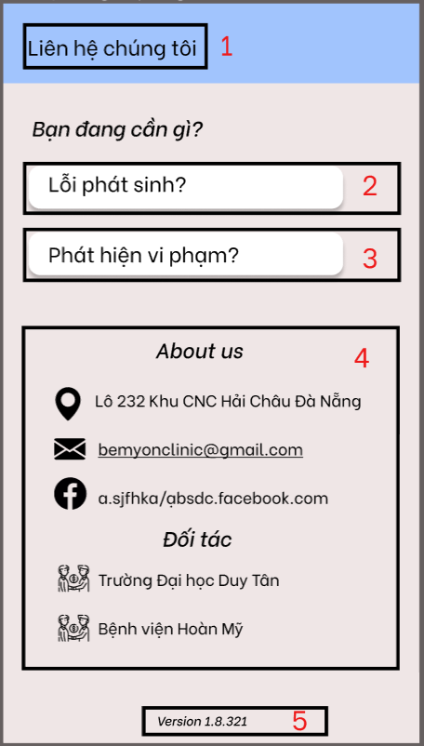

ID | Condition | Control Type | Target
1 | Nothing | TextView | Show page’s name
2 | Press | Button | The application feedback dialog show up
3 | Press | Button | The application feedback dialog show up
5 | Nothing | TextView | Show application’s information
6 | Nothing | TextView | Show the version of the app

2.3.22 Application feedback dialog

ID | Condition | Control Type | Target
1 | Texting | EditText | Enter the feedback for application
2 | Press | Button | Sending the feedback to admin
3 | Press | Button | Cancel feedback dialog

